# Company User Guide

### How to create new user?

1. Open ETE Reman Quick Quote Site - http://<ETE Reman Domain Name>
2. Login using your e-mail and password

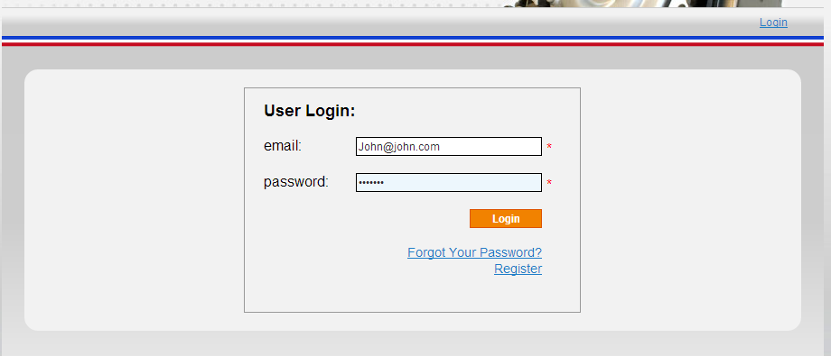

1. Click on "Register New User" link

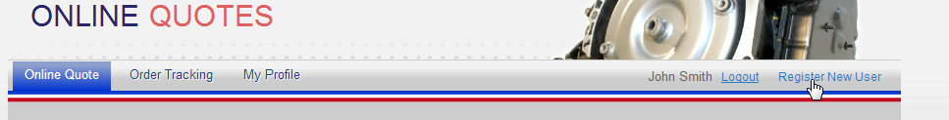

1. Fill all necessary fields and press submit button

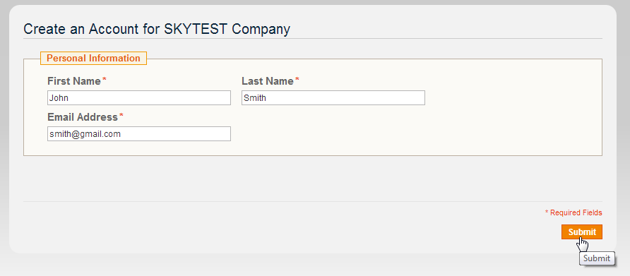

*The confirmation email will be sent to the email used for registration of new user.*

1. Final step should be done by new user, he should open confirmation email and pass verification process (just click on the verification link). Link will be opened in default browser and verification process will be completed. User can login to the site and make orders.

